## 

## 



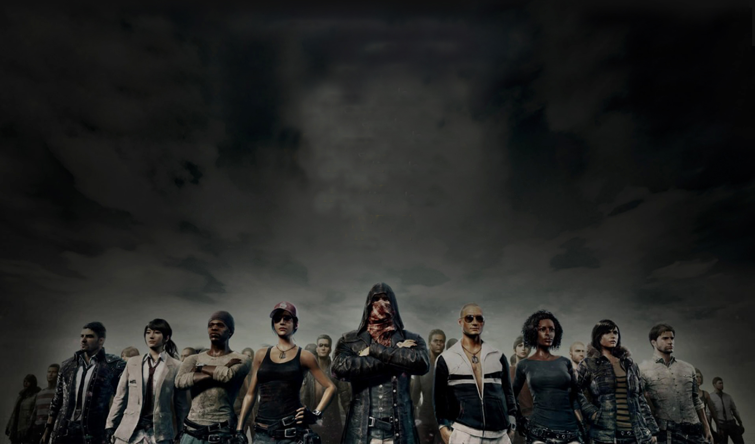

2

|  |  |
| --- | --- |
| Solo Competition | Team Competition |
| * You are on your own * Seat Number * Solo Award | * **You must have a team of 4 people** * **Each team must have a unique team name** * **Station Number where group sits together** * **Team award** |
| Each player must have a unique username  Each player must enter their registration  Each event depends on the kind of map(s) in the competition  Score is based on kill, style (ie headshot), and placing  We can probably store information about weapons and items on the map.  Competition is separated by Finals and semi-finals.  There are age divisions separated from pro-gamers. | |

2

3



**Team Battle (Example)**



3